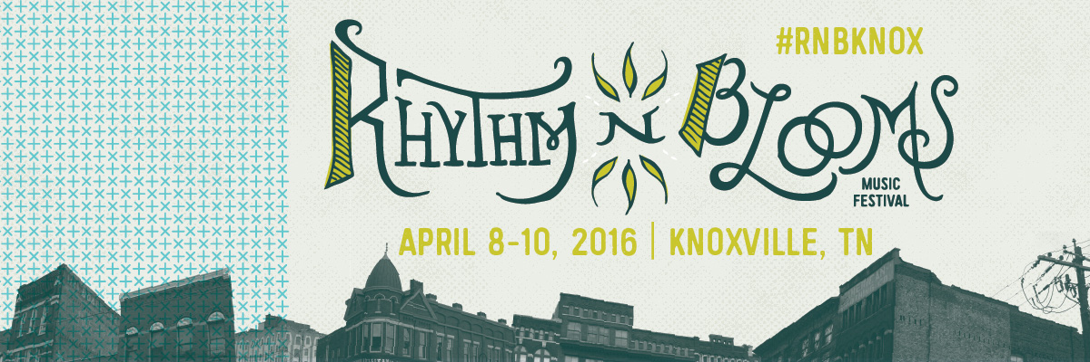

Contact: Katharine Torbett Chyna Brackeen
Dogwood Arts Attack Monkey Productions
ktorbett@dogwoodarts.com chyna@attackmonkey.net
865.246.4392 865.223.4944

FOR IMMEDIATE RELEASE

Rhythm N’ Blooms Music Festival Announces Early Bird Ticket Sale

Knoxville, Tennessee [October 12, 2015]
The festival that has brought artists like The Decemberists, Jason Isbell, Dawes, Amos Lee, and so many more returns to Knoxville’s historic Old City and Jackson Avenue neighborhood, April 8th – 10th in 2016. Rhythm N’ Blooms Music Festival is a festival that’s just as much about the city of Knoxville as it is about music. With the Great Smoky Mountains as the backdrop and the Historic Old City as our stage, Rhythm N' Blooms offers a festive yet intimate musical experience that results in a weekend like no other in the “Scruffy City”. Rhythm N’ Blooms highlights the soundtrack and celebrates the crossroads of Knoxville’s varied music history.

Early Bird Ticket Sales Tuesday, October 13th:
A limited number of REDUCED PRICE Festival Passes and VIP Festival Passes are going on sale Tuesday morning, October 13th at 10:00am EST. Regular 3-Day Festival Passes will be available for $50 and VIP 3-Day Festival Passes will be available for $100. These passes [and prices] will be available until they are sold out. Visit rhythmnbloomsfest.com to purchase these early bird tickets while they last.

Web: www.rhythmnbloomsfest.com
Twitter: @rhythmnblooms / #RnBKnox
Instagram: @rhythmnbloomsfest
Facebook: Rhythm N’ Blooms Festival

Rhythm N’ Blooms Music Festival is presented by Cherokee Distributing Company and produced in partnership by Dogwood Arts and Attack Monkey Productions.

About Dogwood Arts: Dogwood Arts, presented by ORNL Federal Credit Union, is a 501(c)3 organization with a mission to promote and celebrate our region’s arts, culture, and natural beauty. For more information on Dogwood Arts, visit www.dogwoodarts.com or call [865] 637.4561.

About Attack Monkey Productions: Founded in 2009, Attack Monkey Productions is a full-service entertainment company specializing in event production and artist management. Attack Monkey Productions seeks out the things that are cool and brings them straight to you. From music to moonshine, the traditional to the avant-garde, AMP specializes in the development and promotion of unique, high quality brands and experiences. For more information, visit www.attackmonkey.net.

###

