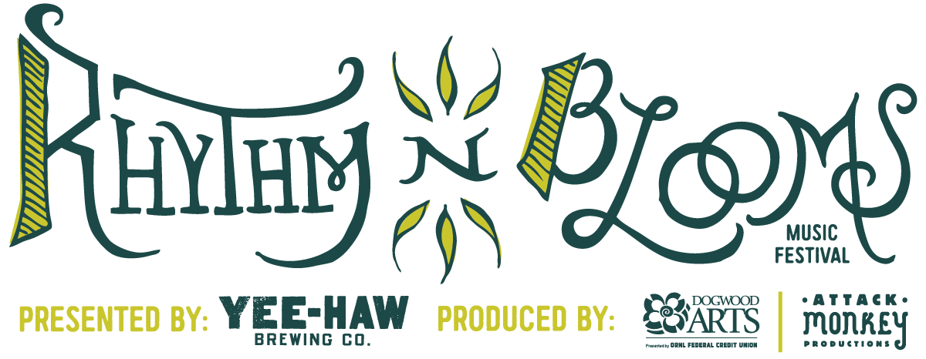

Contact: Katharine Torbett Chyna Brackeen
Dogwood Arts Attack Monkey Productions
ktorbett@dogwoodarts.com chyna@attackmonkey.net
865.246.4392 865.223.4944

FOR IMMEDIATE RELEASE

Rhythm N’ Blooms’ First Peek at 2016 Lineup with an Artist Reveal Puzzle

Knoxville, Tennessee [November 30, 2015]
Rhythm N’ Blooms previously announced it will be releasing the first artist lineup reveal today for the 2016 Music Festival. The announcement is less straightforward than one might think. This year fans are getting a list of clues that will put their knowledge of music to the test. Rhythm N’ Blooms recently published an artist reveal crossword puzzle on their website. Each clue on the crossword corresponds with one of the artists playing the 2016 event. Fans who solve the puzzle will receive a coupon for discounted Festival Passes as part of Cyber Monday.

The crossword puzzle has some challenging clues, but the Festival is encouraging fans to work together using the hashtag #RnBPuzzle. The Festival shared clues across social media last week for people to collaborate with one another and find the answers. In essence, the fans are helping to make this first artist lineup announcement! The answers to this artist puzzle will be revealed on Tuesday, December 1st. Head over to www.rhythmnbloomsfest.com/lineup and see how many artists you can guess.

Rhythm N’ Blooms will be returning to Knoxville’s historic Old City and Jackson Avenue neighborhood, April 8th – 10th in 2016. Tickets are available on at www.rhythmnbloomsfest.com

Web: www.rhythmnbloomsfest.com
Twitter: @rhythmnblooms / #RnBKnox
Instagram: @rhythmnbloomsfest
Facebook: Rhythm N’ Blooms Festival

Rhythm N’ Blooms Music Festival is presented by Yee-Haw Brewing Company and produced in partnership by Dogwood Arts and Attack Monkey Productions.

About Yee-Haw Brewing Company: Yee-Haw is about fun, and about balance. We will provide a mix of the finest ales and lagers. Our beer will be bold and flavorful, but easy to drink. Our year round Pilsner, Pale Ale, Eighty shilling Scottish Ale and Dunkel dark lager are there to be your go-to staples, while our seasonals will give you a chance to try something exciting and new. Whichever flavor fits your fancy, order it loudly, and don't forget to share. For more information visit

About Dogwood Arts: Dogwood Arts, presented by ORNL Federal Credit Union, is a 501(c)3 organization with a mission to promote and celebrate our region’s arts, culture, and natural beauty. For more information on Dogwood Arts, visit www.dogwoodarts.com or call [865] 637.4561.

About Attack Monkey Productions: Founded in 2009, Attack Monkey Productions is a full-service entertainment company specializing in event production and artist management. Attack Monkey Productions seeks out the things that are cool and brings them straight to you. From music to moonshine, the traditional to the avant-garde, AMP specializes in the development and promotion of unique, high quality brands and experiences. For more information, visit www.attackmonkey.net.

###

