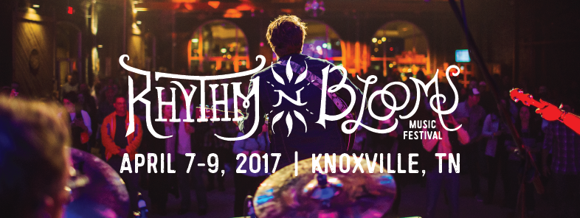

Contact: Katharine Torbett Chyna Brackeen
Dogwood Arts Attack Monkey Productions
ktorbett@dogwoodarts.com chyna@attackmonkey.net
865.246.4392 865.223.4944

FOR IMMEDIATE RELEASE

Rhythm N’ Blooms Music Festival Announces Early Bird Ticket Sale

Knoxville, Tennessee [November 11, 2016]
The festival that has featured The Decemberists, Jason Isbell, Chris Stapleton, The Mavericks, Margo Price, St. Paul & The Broken Bones, and so many more returns to Downtown Knoxville’s historic Old City, April 7th – 9th in 2017. With the Great Smoky Mountains as the backdrop and the Historic Old City as our stage, the Rhythm N' Blooms Music Festival offers a unique and intimate musical experience like no other in our incredible “Scruffy City”.

Early Bird Ticket Sales Friday, November 11th:
A limited number of REDUCED PRICE General Admission Festival Passes and VIP Festival Passes are going on sale Friday morning, November 11th at 10:00am EST. Regular 3-Day Festival Passes will be available for $65 each and VIP 3-Day Festival Passes will be available for $150 each. These passes [and prices] will be available until they are sold out. Visit rhythmnbloomsfest.com to purchase these early bird tickets while they last.

Web: www.rhythmnbloomsfest.com
Twitter: @rhythmnblooms / #RnBKnox
Instagram: @rhythmnbloomsfest
Facebook: Rhythm N’ Blooms Festival

Rhythm N’ Blooms Music Festival is presented by Yee-Haw Brewing Company and produced in partnership by Dogwood Arts and Attack Monkey Productions.

About Yee-Haw Brewing Company: Founded in late 2014, Yee-Haw Brewing Co., is a production brewery and taproom located in a historic railroad depot built in the late 1800s in Johnson City, TN. Yee-Haw focuses on brewing approachable and drinkable ales and lagers that celebrate good times and good company. With their passion for using only top-quality ingredients, Yee-Haw Brewing Co. is growing quickly by expanding their sales throughout Tennessee, Virginia and beyond.

About Dogwood Arts: Dogwood Arts, presented by ORNL Federal Credit Union, is a 501(c)3 organization with a mission to promote and celebrate our region’s art, culture, and natural beauty. For more information on Dogwood Arts, visit www.dogwoodarts.com or call [865] 637.4561.

About Attack Monkey Productions: Founded in 2009, Attack Monkey Productions is a full-service entertainment company specializing in event production and artist management. Attack Monkey Productions seeks out the things that are cool and brings them straight to you. From music to moonshine, the traditional to the avant-garde, AMP specializes in the development and promotion of unique, high quality brands and experiences. For more information, visit www.attackmonkey.net.

###

